Weathe Report

The DHT11 is a basic, ultra low-cost digital temperature and humidity sensor. It uses a capacitive humidity sensor and a thermistor to measure the surrounding air, and spits out a digital signal on the data pin (no analog input pins needed). Its fairly simple to use, but requires careful timing to grab data.
DHT11 Sensor:
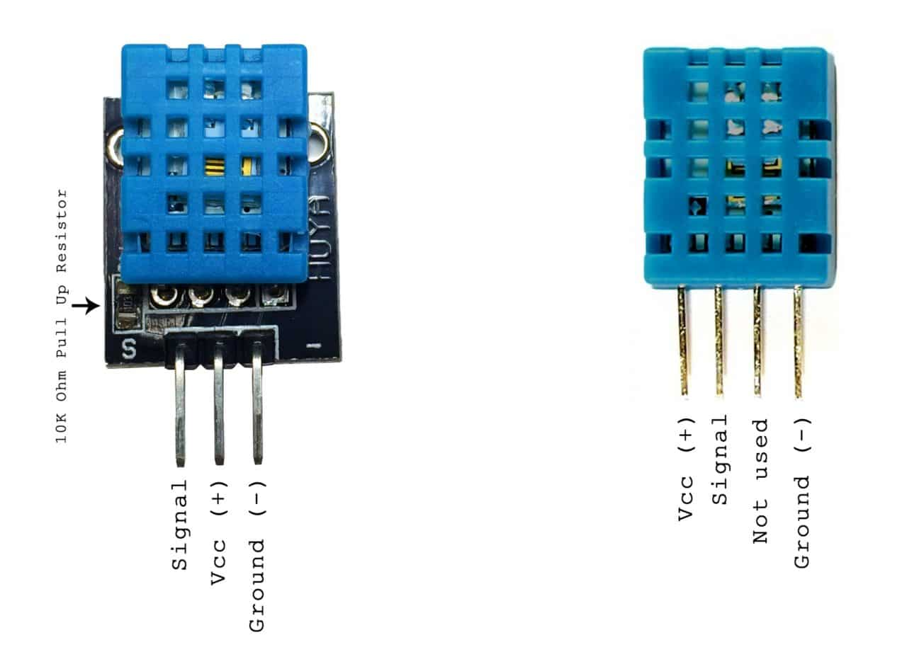

Features of DHT11 Sensor
- Cheap in Price.
- 3 to 5V power and I/O
- 2.5mA max current use during conversion (while requesting data)
- Good for 20-80% humidity readings with 5% accuracy
- Good for 0-50°C temperature readings ±2°C accuracy
- No over 1Hz rate (once every second)
- Body size 15.5mm x 12mm x 5.5mm
- 3 pins with 0.1″ spacing

Arduino Uno:
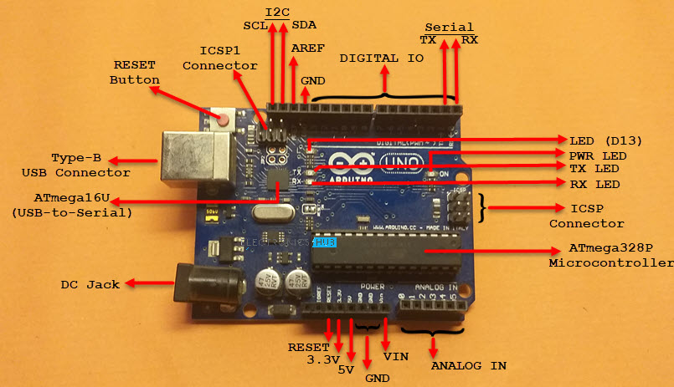

Arduino Uno is a microcontroller board based on the ATmega328P (datasheet). It has 14 digital input/output pins (of which 6 can be used as PWM outputs), 6 analog inputs, a 16 MHz ceramic resonator (CSTCE16M0V53-R0), a USB connection, a power jack, an ICSP header and a reset button. It contains everything needed to support the microcontroller; simply connect it to a computer with a USB cable or power it with a AC-to-DC adapter or battery to get started.. You can tinker with your Uno without worrying too much about doing something wrong, worst case scenario you can replace the chip for a few dollars and start over again.

Components required
The following are the list of components that are required to interface DHT11 sensor with Arduino and 16×2 LCD Display.
- Arduino UNO
- DHT11 Temperature and Humidity Sensor
- 10K Potentiometer
- 16×2 LCD Screen
- Breadboard
- Jumper Wires

Connection:
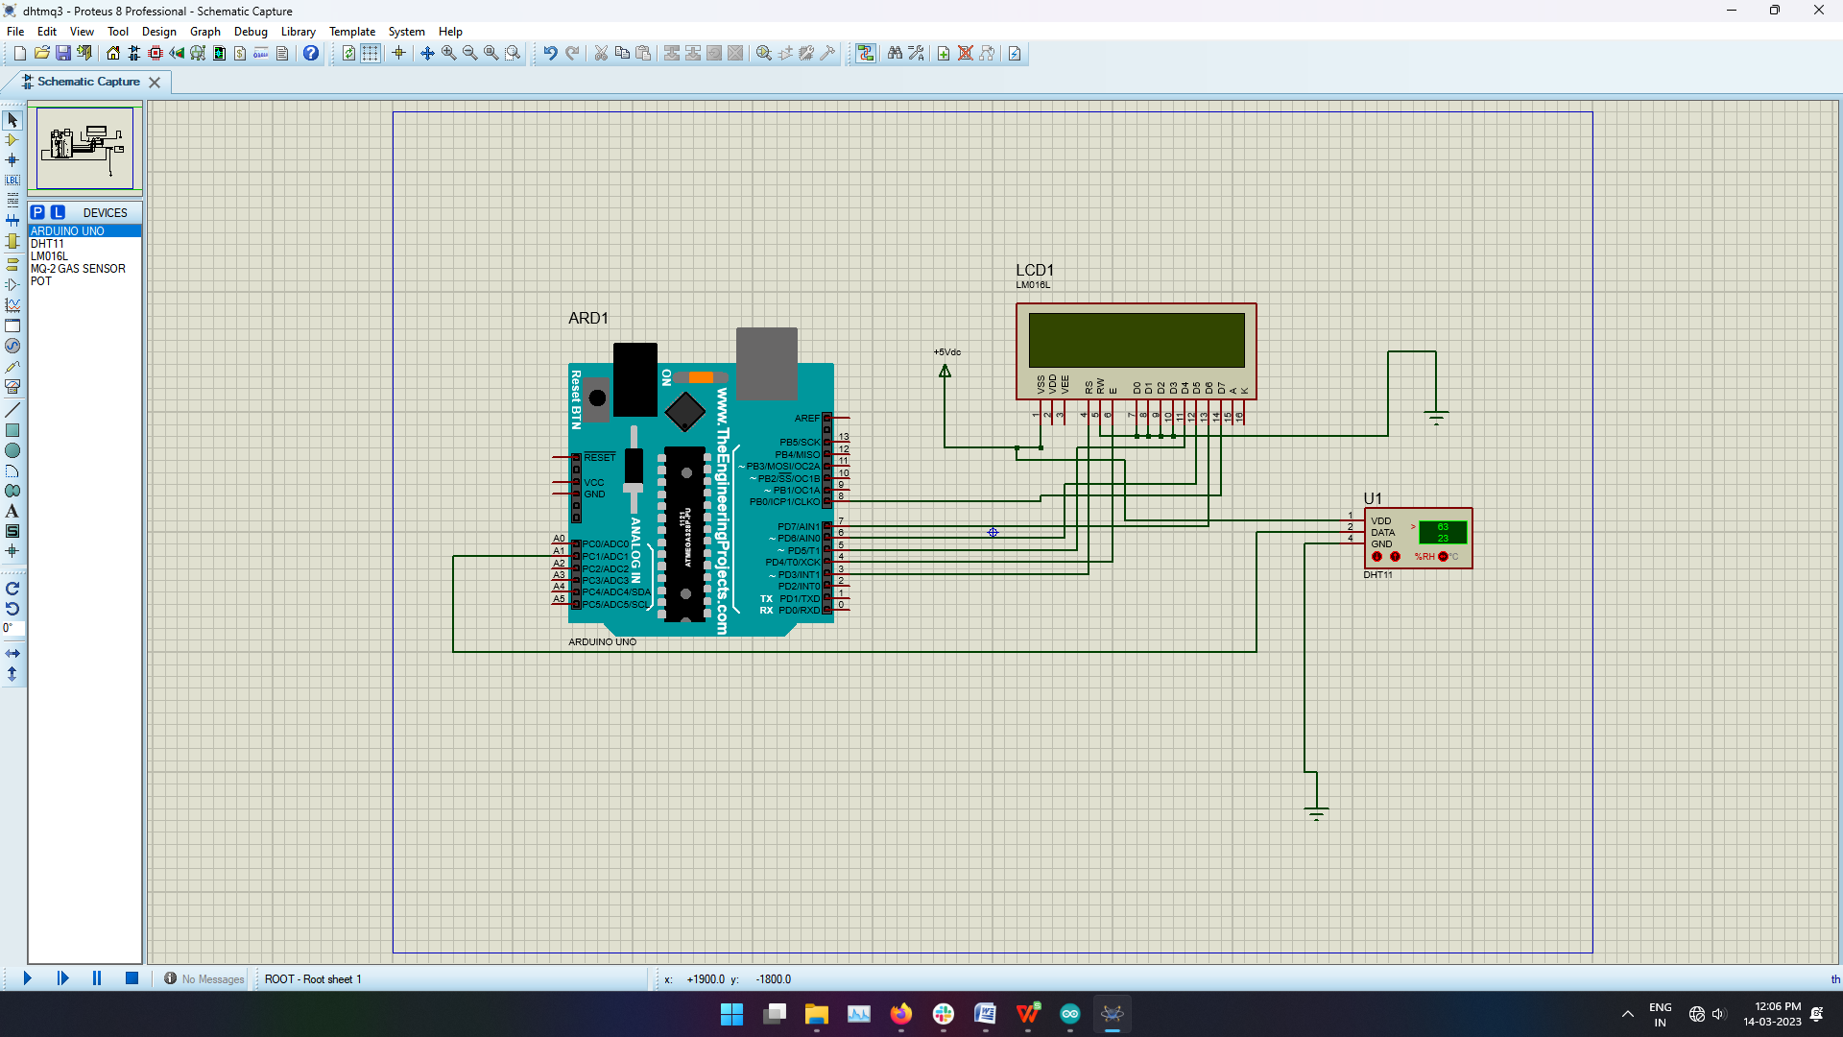
Program:
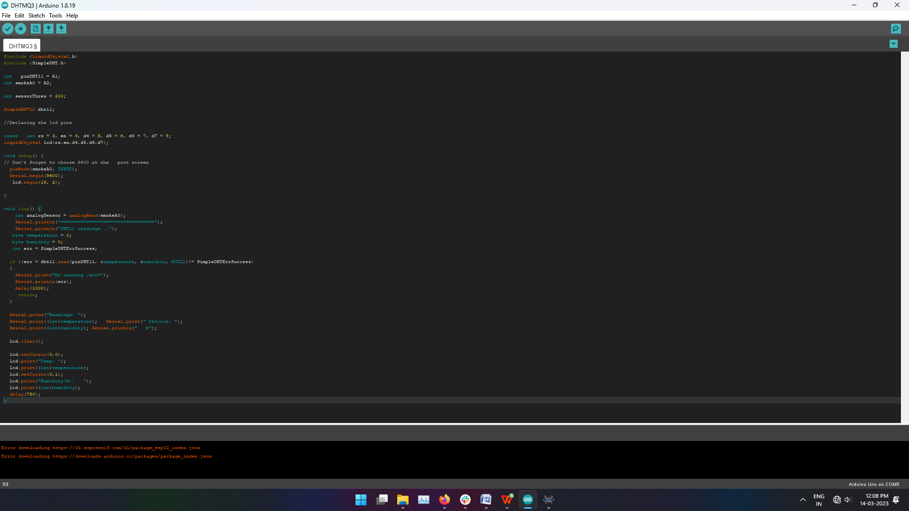
OUTPUT:
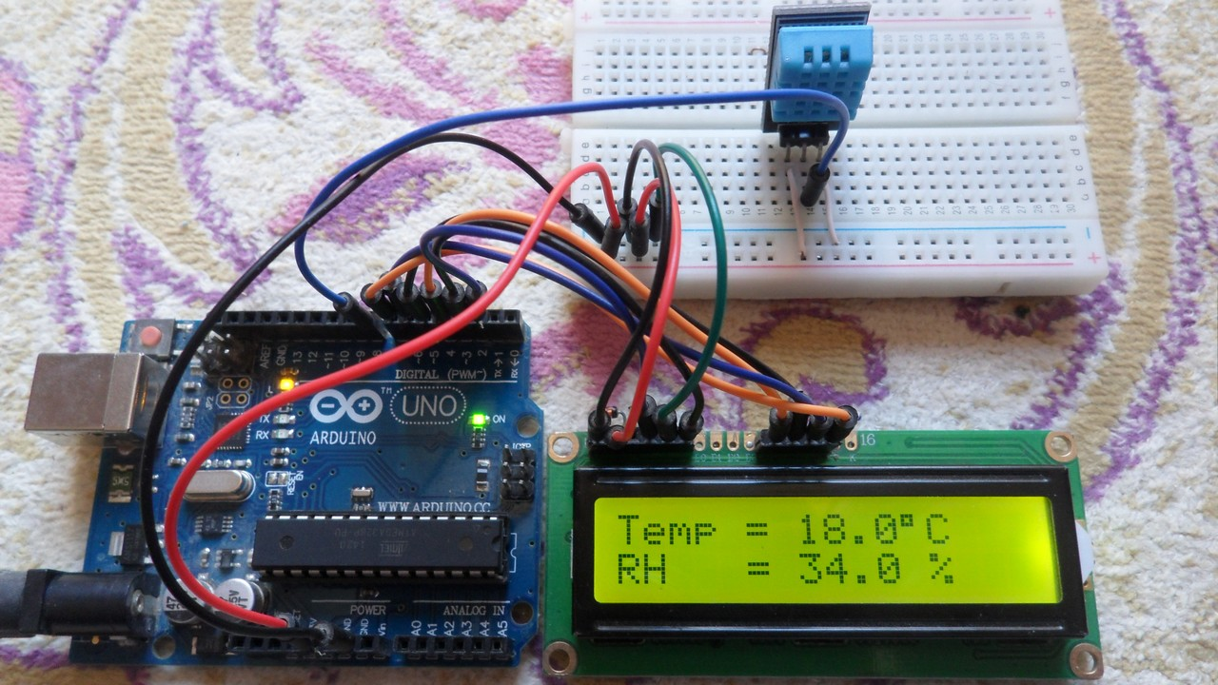

Conclusion:
Finally, we have completed Interfacing DHT11 Humidity and Temperature Sensor with Arduino & LCD. Now, you can see the Humidity and Temperature from the LCD Screen. We hope you found this project useful.

